Virtual Club Events

Dear Member
Since the first lockdown in March 2020 the Club has broadcast an incredible 70 virtual Club events with over 3000 attendees. In addition, another 3000 views have been made on catch up using Vimeo and You Tube.
The Club Events Committee has been working hard behind the scenes arranging a myriad of guest speakers. The very first event, an Early Evening Lecture hosted by Matthew Taylor with Professor Rana Mitter on 12th May 2020, remains the highest attended event with 230 viewers and a further 205 watching post event via Vimeo. The Club is delighted to welcome back Professor Mitter as guest speaker at another Early Evening Lecture on the 13th April.
The upcoming In Conversation with Lord Heseltine hosted by Richard Price may challenge the Rana Mitter event for top spot with over 150 members having already registered to attend. Book now!
Professor Rana Mitter, Early Evening Lecture – China’s Approach to the emergence of Covid-19 on 12th May 2020

Types of events broadcast range from Wine Tastings, Writers’ Talks, In Conversation with…, Musical Conversation, Early Evening Lectures, Musical Recitals and Play Readings by the O&C Players. I think you will agree that there has been something for everyone. Some Interest Groups, notably the Literature Table and the Maths and Science Group, have also held events.
Speakers and subjects have ranged from Lord Adonis (Labour’s Churchill), Lord Barwell (The Politics of the Pandemic), Loyd Grossman (An Elephant in Rome) and Professor John Gooch (Mussolini’s Wars).
Younger Members also have a packed calendar along with monthly Members’ Receptions hosted by Bob Smith.

Pygmalion by George Bernard Shaw read by the O&C Players on 20th January 2021
Viewers have tuned in to live events from every continent and countries as far and wide as Serbia, New Zealand, China, and Columbia with the USA having the highest viewers outside of the UK.
Post event viewing via Vimeo stretches this further with views from Japan, Mexico, British Virgin Islands, Bangladesh and a further 49 countries in between.

Post event views via Vimeo

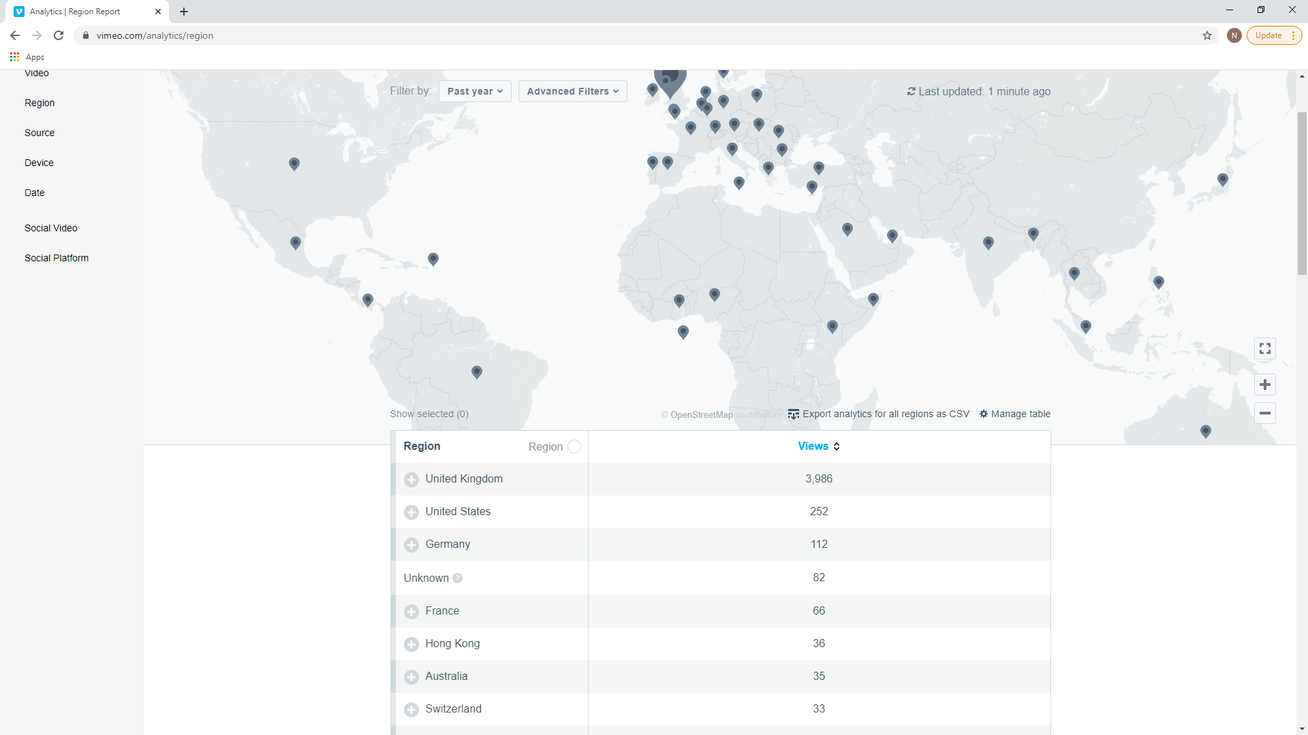
The Virtual Event calendar is filling up nicely with an exciting programme for the rest of 2021. Keep an eye on the ‘More Dates for Your Diary’ section of the eNewsletter for upcoming speakers and dates.
There is no doubt that we all look forward to returning to the Club to attend events live in the Club with the conviviality of fellow members. Virtual events will, however, continue providing entertainment wherever you are based in the world whether as an overseas member, a country member or just not able to visit the Club house for whatever reason. Purely virtual events will be provided as well as ‘hybrid’ events where a recording of actual events in the Club house will be made available at a later date.
A reminder that most events since March 2020 are available for viewing on the Club Website.
If you have not yet attended a virtual event, I encourage you to do so – what better way to spend an evening than enjoying a Club event on the sofa with a refreshment!
The Club looks forward to welcoming members back into the Club house and seeing you virtually on Zoom.
Kind regards
Sara Clark
Chair of Club Events Committee

